Pg. 232 – 236 Java Programming *A comprehensive Introduction*

**Section 1: Define**

Static variables- static variable is a variable that has been allocated statically—whose lifetime or "extent" extends across the entire run of the program.

Static methods- Java static method program: static methods in Java can be called without creating an object of class.

**ONLINE RESOURCE:** http://tutorials.jenkov.com/java-io/file.html

**Understand and define methods in the Java File class-**

java.io.File *file* = **new** java.io.File("*filelocation.filetype*");

System.out.println("Does it exist?" + file.exists());

System.out.println("The file has " + file.length() + " bytes ");

System.out.println("Can it be read?" + file.canRead());

System.out.println("Can it be written to?" + file.canWrite());

System.out.println("Is it a directory" + file.isDirectory());

System.out.println("Is it a file?" + file.isFile());

System.out.println("Is it absolute? " + file.isAbsolute());

System.out.println("Absolute path is " + file.getAbsolutePath();

System.out.println("Is it Hidden? " + file.isHidden());

System.out.println("Last Modified on " + file.lastModified());

System.out.println("Last Modified on " +

**new** java.util.Date(file.lastModified()));

**throws** Exception vs Error-

**Understand and define methods in the PrintWriter class-**

java.io.PrintWriter output = new java.io.PrintWriter(file);

**Programming Tasks:**

Task 1- Task 1- Page 252, #20 Java Programming *A comprehensive Introduction*

Modified

Implement a class **Arrayplus1()** that takes an integer array **data** and an **int x** as its size. Create a method inside the class **Arrayplus1()**

that creates a new array whose length is one greater than **data’s** length.

Then create a method to copy all data’s elements into the new array and add the value of x into the last element of the array. (Search for java methods for copying Arrays)

Create a separate **print()** class that takes the newly created array and prints its contents in a text file.

Use main to operate your program.

Attach Snipping Photos of source code and output.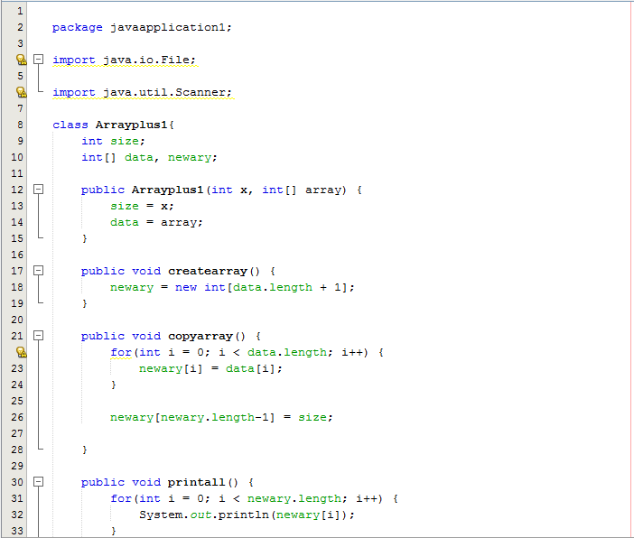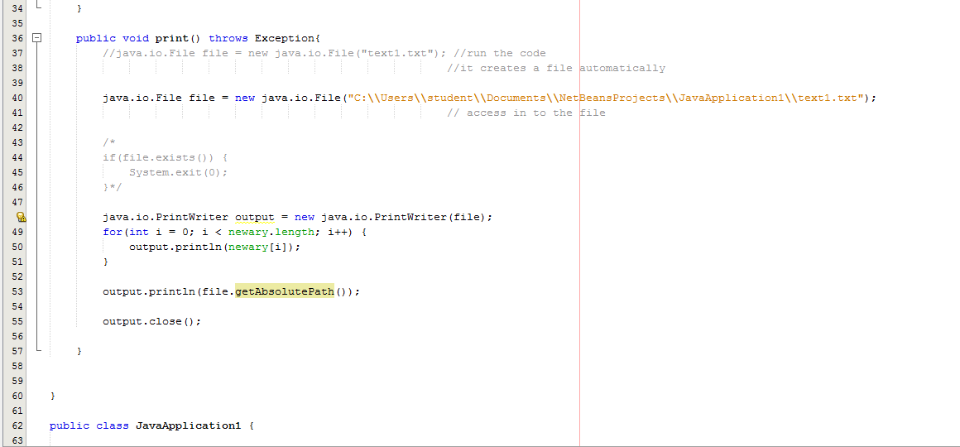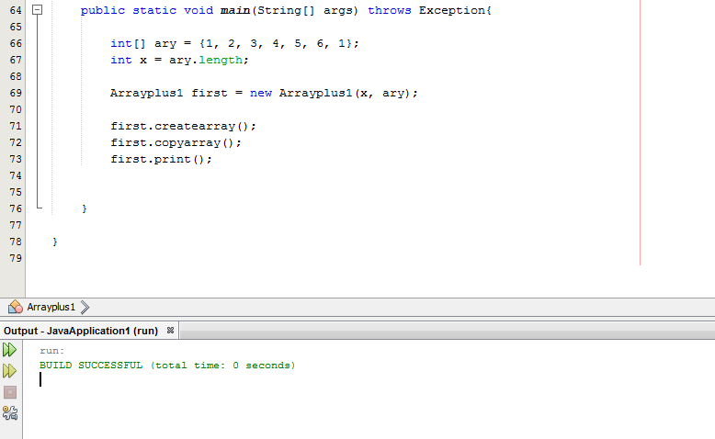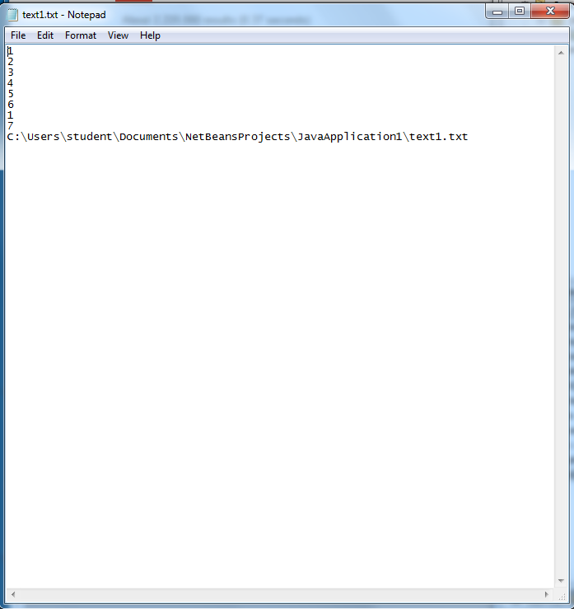

Task 2- Enhance Assignment #4 Task2

Create a class that allows the user to input 7 days of the week which will be stored in an Array[] of strings, and the corresponding temperature for each day which will be stored in an Array[] of doubles. Prompt the user before she enters each new day and temperature.

Output the day and corresponding temperature entered in a println output.

Then create a static method in the “programmer created class” for averaging the temperatures for the week.

**Output:** Print the average temperature for the week.

Attach Snipping photos of Source code(programmer created class, println output)

